DEVELOP THE PYTHON SCRIPT

Team ID : PNT2022TMID03062

Project Name - SIGNS WITH SMART CONNECTIVITY FOR BETTER ROAD SAFETY

Create a code snippet using python to

* **Extract weather data from OpenWeatherMap using APIs**
* **Send the extracted data to the cloud**
* **Receive data from the cloud and view it in the python compiler**

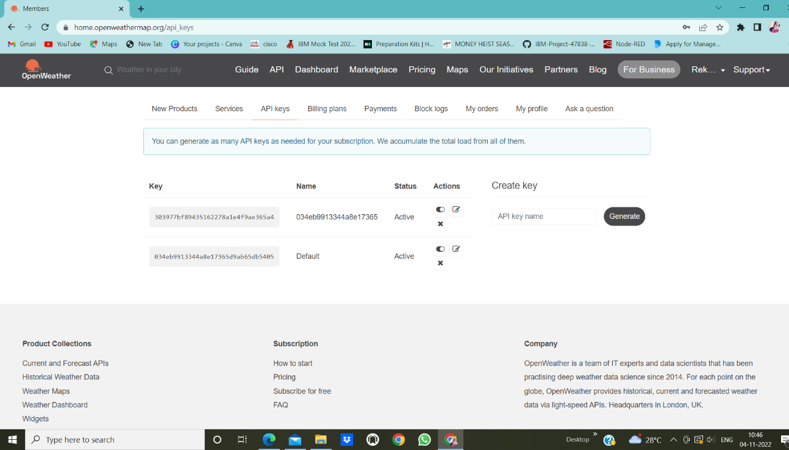

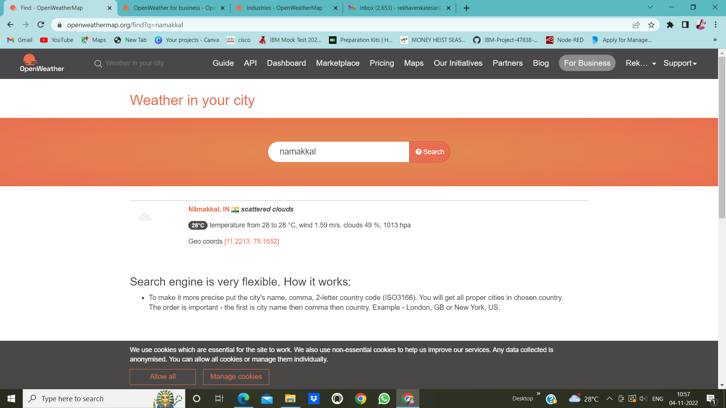

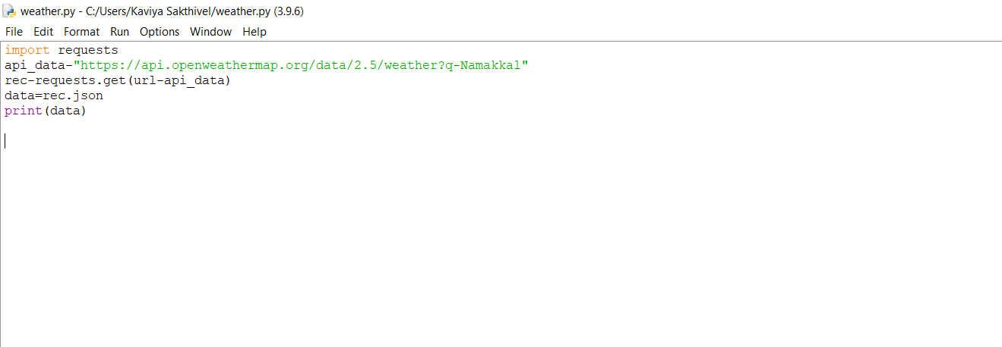



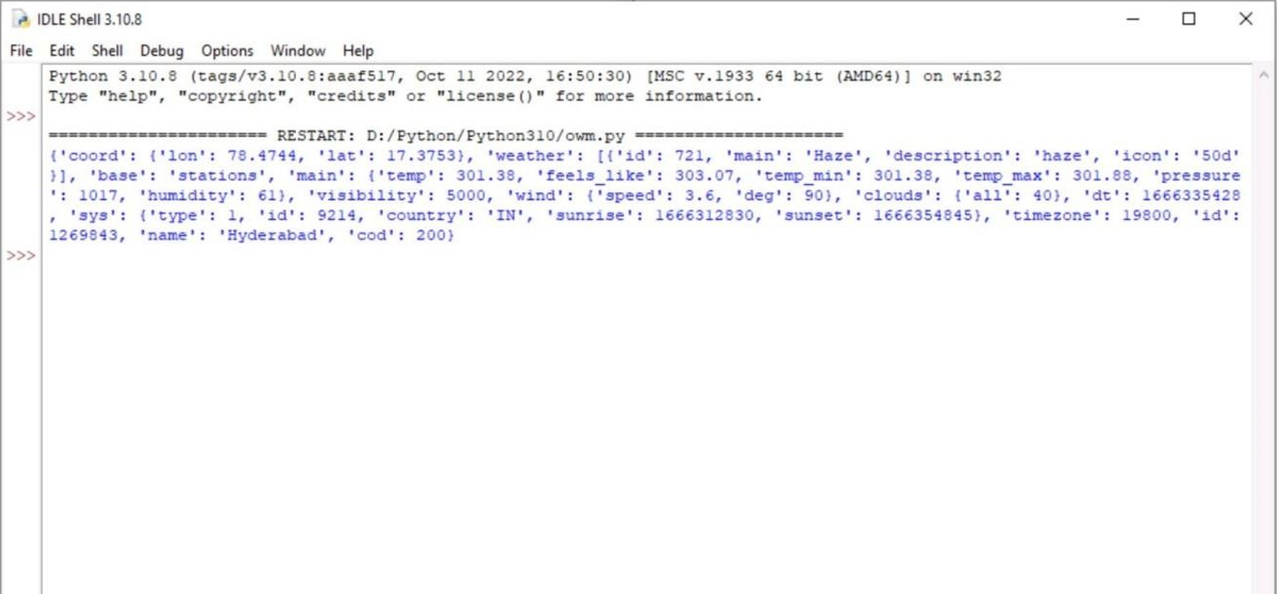

}



‘ Namakkal



‘Namakkal

